How to receive a purchase order

1. Purchase/Receiving 🡪 Purchase Order
2. Search the created order
3. Click on Receive Current PO

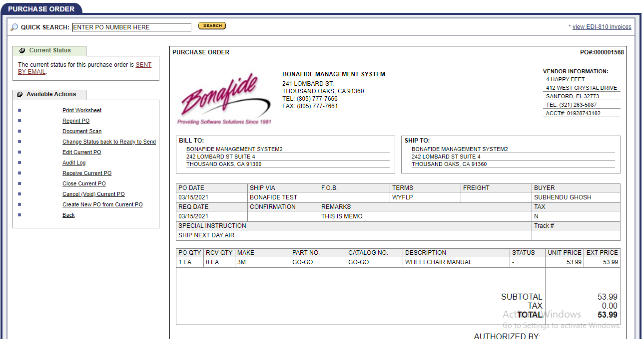

1. Enter all required data and click on “Next Step”

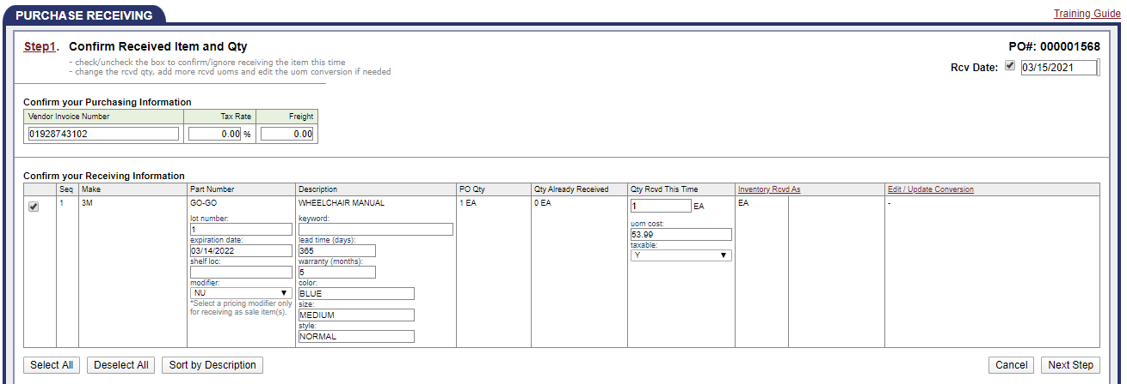

1. Assign SKU and click on “Next Step”

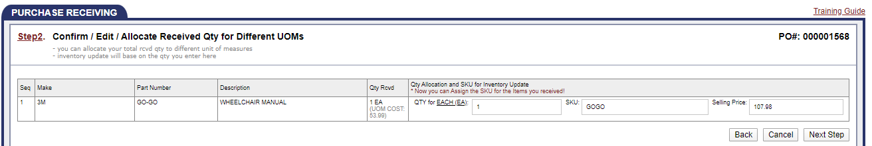

1. Click on “Confirm Receiving”

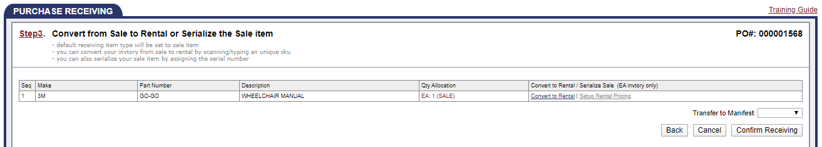

1. Click on “Finish”

